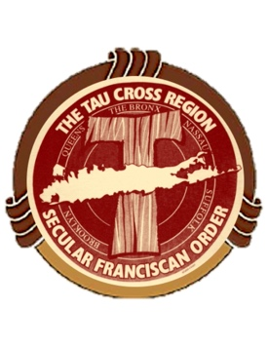
The Tau Cross Region
Advent day Retreat
Theme:
Cause of Our Joy: Nothing is Impossible with God
Saturday:
December 10, 2022
We will begin with Holy Mass
9am -12pm
Presenter
Br. Richard Contino osf
Where:
St Anthony’s HS 275 Wolf Hill Rd Huntington, NY
Zoom Link https://us02web.zoom.us/j/87303076452
Meeting ID: 873 0307 6452
Dial by your location
+1 646 558 8656 US (New York)
In Person and Virtual availability
Please let us know how you will be attending!
(Tear off this section)
**************************************************************************************************
**Limited Seats available**

RSVP needed send and make checks payable to:
Peter D’Amato ofs PO Box 447 Miller Place NY 11764

Who will be attending:

In person: _____________________________________________$15.00 donation

By Zoom______________________________________________Free will offering

