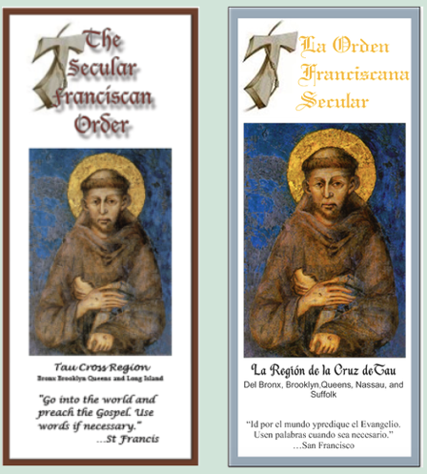
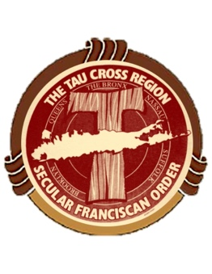
Tau Cross Region
Secular Franciscan Vocation Flyer
Order Form

I request the following number of packs of the Tau Cross Region Vocation Flyer.
(Packs are sold in quantities of 100 for $38 OR quantity of 50 for $20)

________ pack(s) of _____________ I have enclosed a check payable to the Tau Cross Region for $__________

English_____________ Spanish________________

Please mail my order to:

Name __________________________________________________________

Address ________________________________________________________

City ____________________________________________________________

State ___________________ Zip ___________________________________

Phone Number _________________________________________________

Name of Fraternity _____________________________________________

Mail this form with your check to: The Regional Formation Director
(Contact Information under Region Council members)

